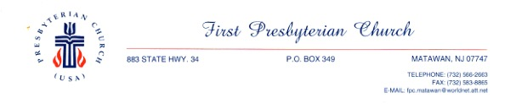

First Presbyterian Church of Matawan
MULTIMEDIA RELEASE FORM
I hereby give my consent for the First Presbyterian Church of Matawan to photograph and/or videotape me and/or my listed minor child(ren) or use photograph(s) or video(s) that already exist of me and/or my listed minor child(ren) that were taken at the First Presbyterian Church of Matawan or a church sponsored/supported activity.

I give the First Presbyterian Church of Matawan permission to publish, exhibit, and distribute these photographs, digital images, videos, and/or audio recordings of me and my listed minor children. I understand that these materials may be displayed on websites owned or sponsored by the First Presbyterian Church of Matawan or used in publications, promotional flyers, and/or educational materials or for any similar purposes without compensation or remuneration.

I understand that the First Presbyterian Church of Matawan owns the copyright to the multimedia material in which I and/or the minors included on this release may appear. The First Presbyterian Church of Matawan does assure that they will convey positive images of myself and the minors who are included on this release form.

I hereby warrant that I am eighteen (18) years old or more and competent to contract in my own name. This release is binding on me and my heirs, assigns, and personal representatives.

Please complete one form per family.

Participant Name(s):

___________________________________ ___________________________________
Print Name Signature
___________________________________ ___________________________________
Print Name Signature

Names of Minor(s):

___________________________ ______________ _____________________________
Print Name Date of birth Parent/Guardian Signature
___________________________ ______________ _____________________________
Print Name Date of birth Parent/Guardian Signature
___________________________ ______________ _____________________________
Print Name Date of birth Parent/Guardian Signature
___________________________ ______________ _____________________________
Print Name Date of birth Parent/Guardian Signature

Date form completed: ____________________________________

Contact details: Phone: __________________________ Email: ________________________

